1. Identify and describe at least one defect or missing feature that was identified when performing the acceptance testing above.

* While doing acceptance testing I didn’t find any defects.

1. Discuss at least 2 refactoring (include before and after code snippets) that you would do following the acceptance testing. (4 marks)

* Deleted the task class from the package task2 since it is code redundant, I can refer to the class task of package task1.
* Refactored the class TwitterTask and ReadingFile class and made a method in the Task Class, so this method can be used in both classes for code reusability.

Task class

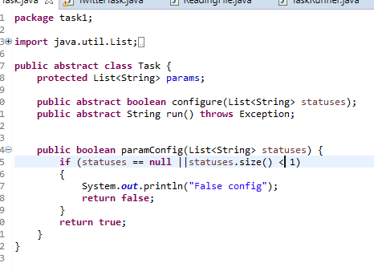

Before TwitterTask

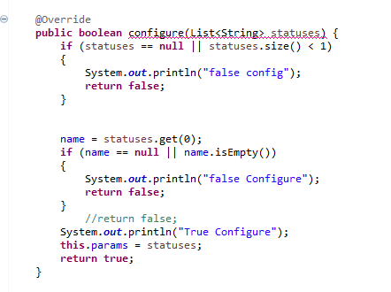

After TwitterTask

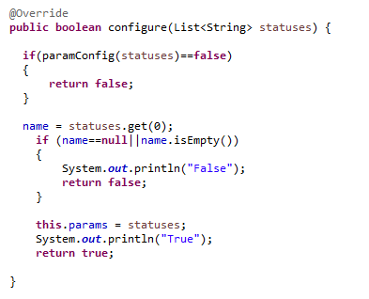

Before ReadingFile

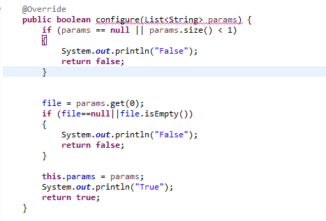

After ReadingFile

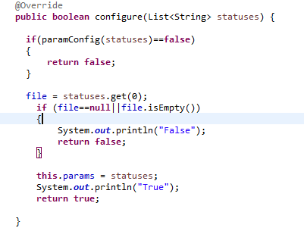

1. Explain the importance Selenium in the process of test-driven development, using your experience in this project or other work you did during the semester.

* Selenium is an important testing tool for quality assurance, it is automatic, user friendly, flexible and can find bugs at an early stage. During this assignment it helped me identify each expected output from the API part and file part and making sure the process of each part is followed by the sequence of the feature file.